1. **Catamaran Hull Drag Force Calculation**

In order to provide the necessary thrust in line with our design criteria, it is an important step to find the drag coefficient and force. Our catamaran hull is aimed to provide thrust that can withstand 5 beafourd intensities. In this direction, it is aimed to provide enough thrust to remain constant against the wind with a speed of 10 m/s blowing from the opposite direction.

The catamaran hull was modeled using the Fusion 360 program. In order to facilitate the assembly and production strategy of our vehicle, The model has been drawn in detail, has been simplified to avoid errors in the simulation environment.

|  |  |
| --- | --- |
| Figure 1 Detailed CAD Model | metin, ekran görüntüsü, vitrin, bilgisayar içeren bir resim  Açıklama otomatik olarak oluşturuldu  Figure 2 Simplified CAD model for analysis |

In order to find the drag coefficient and force of the vehicle, flow analysis was performed with the fluent module over the Ansys program. The speed of the vehicle was determined as 10m/s, our vehicle was transferred to ansys with a ratio of 1:1, multiflow flow was used with the k-epsilon turbulence model and the analyzes were made with these presuppositions.

In accordance with the simulation, the drag force graph below was obtained.(120N)

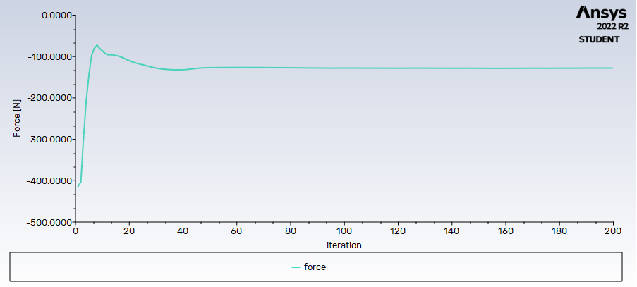

Figure 3 Force-Iteration Graph

When the shape of the flow is examined, it can be said that there is a turbulence behind the catamaran. When the pressure data in the same region is examined, there does not appear to be a problem. But, when the speed data is examined, the turbulence that occurs in this region may damage the vehicle's running, albeit a little. However, if we consider that this speed is the highest point of the catamaran and is much higher than the standard operating speeds, the turbulence that occurs at these speeds will not harm the course of our vehicle under standard operating conditions.

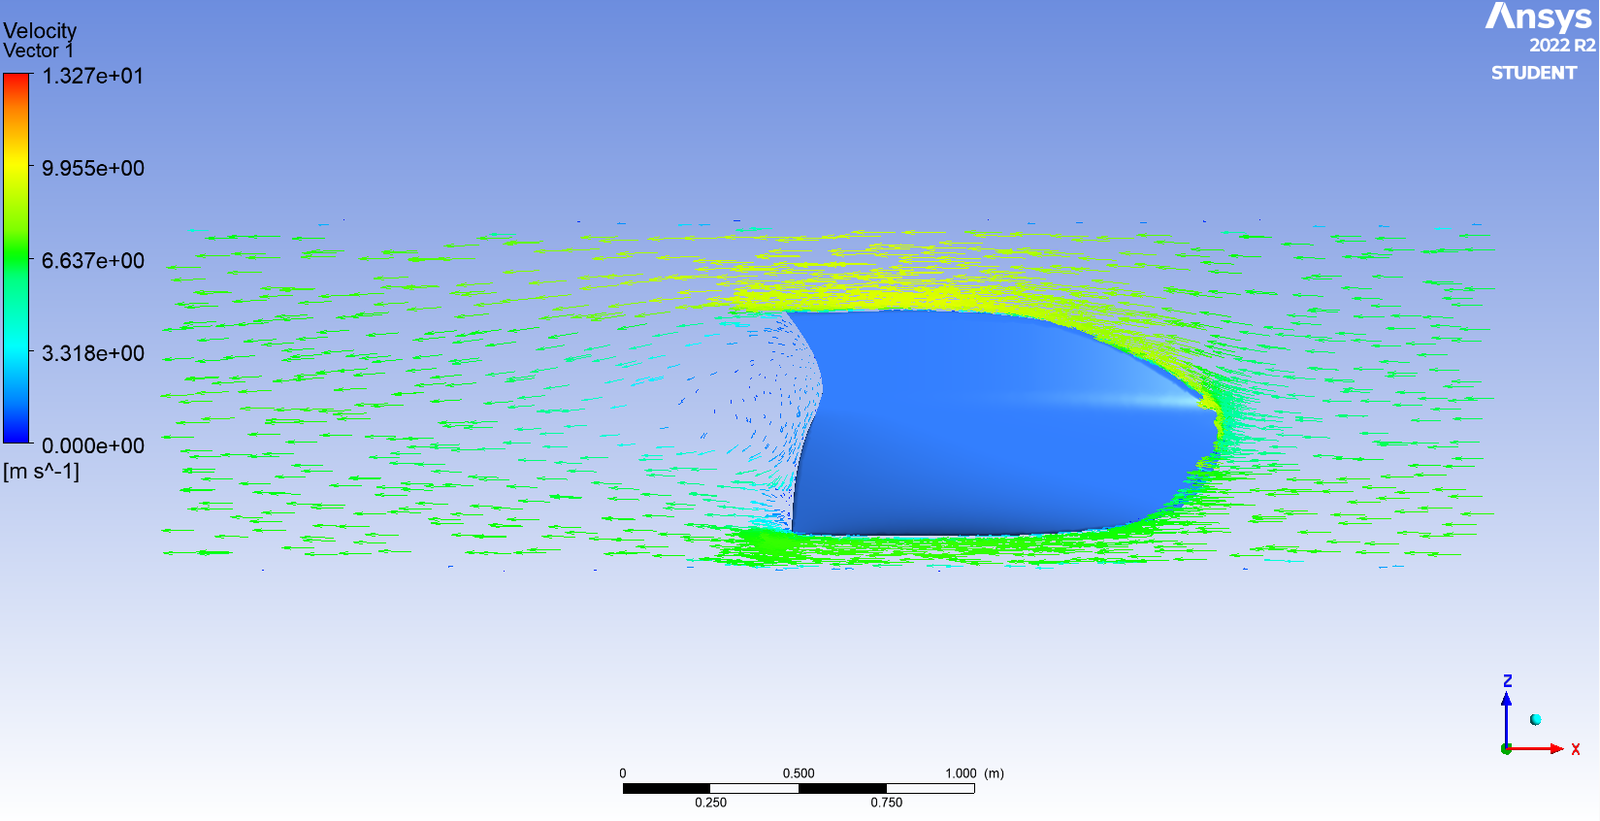

Figure 4 Velocity Vector distribution

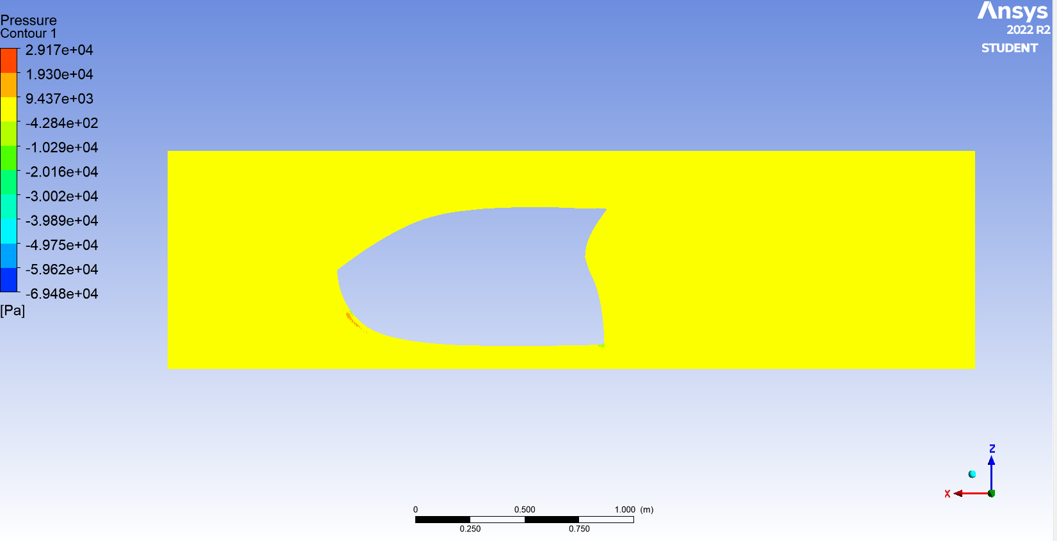

Figure 5 Pressure distribution

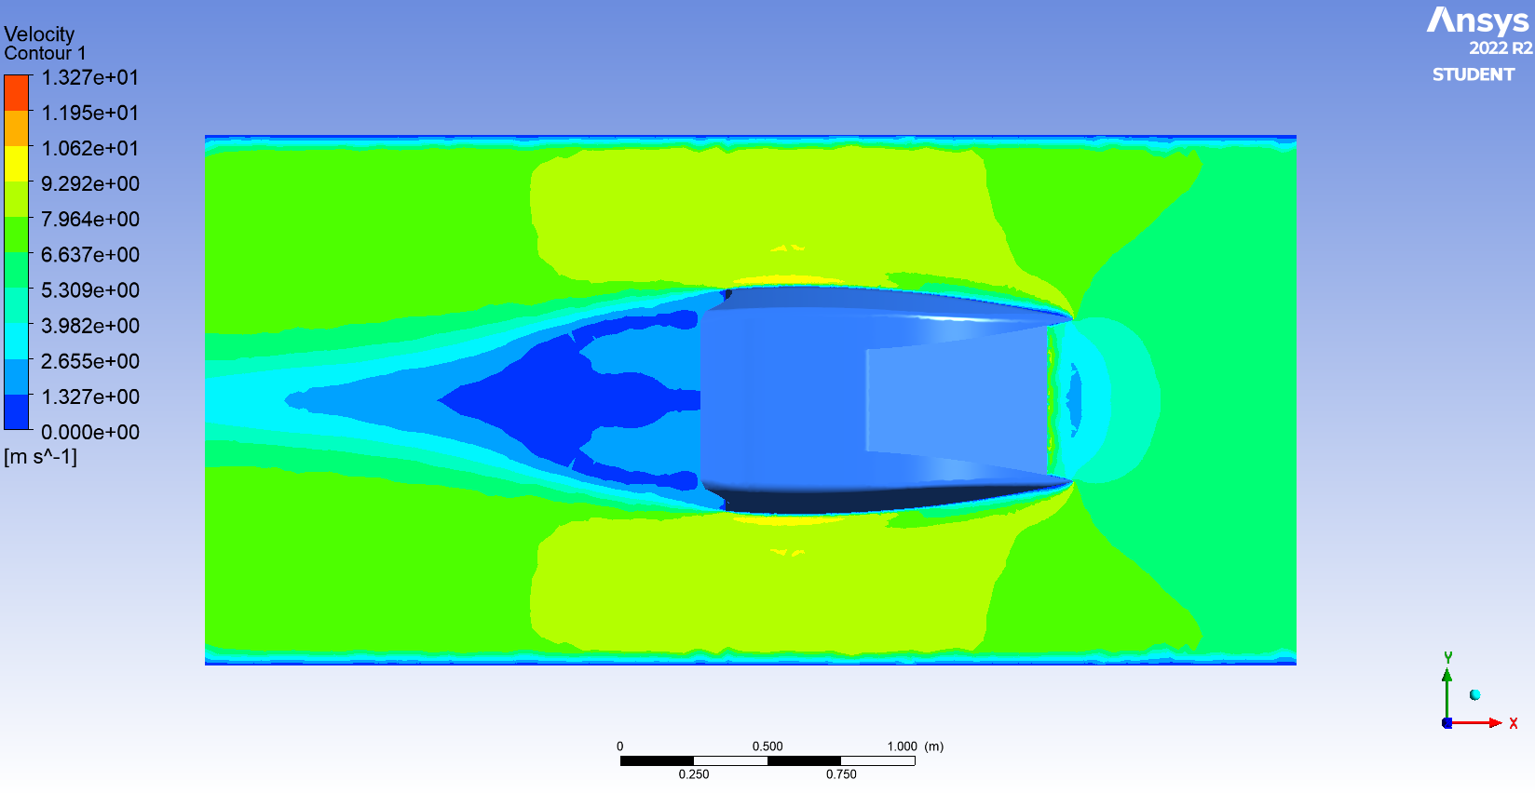

Figure 6 Top Velocity Vector Contour

1. **Sample Mechanism Drag Force Calculation**
   1. **Vertical Force Analysis**

Considering the main task of our vehicle, it is a very important step to calculate the force that our engine should provide while pulling the sample tube up from the depth where it is lowered.

In this purpose, the horizontal and vertical forces of the sample tube should be calculated separately and our motor should be sufficient against the resultant force.

The sample tube drawn in the Fusion 360 program has been simplified for analysis. While performing our analysis, the sample mechanism was pulled up at a speed of 10m/s, but this condition only applied with emergency situations. In standard use, the process will take place at lower speeds.

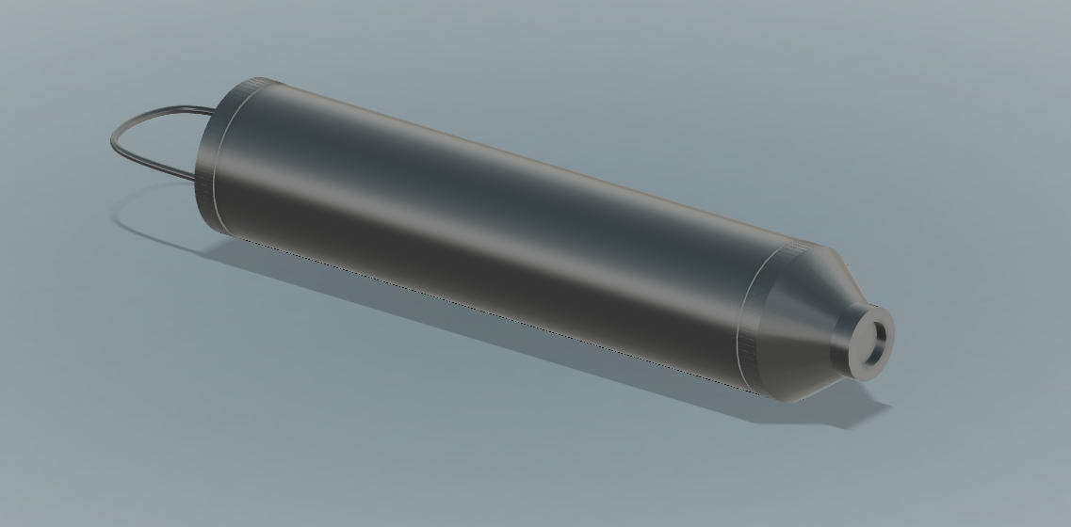

Figure 7 Sample Tube CAD drawing

In order to find the drag coefficient and force of the sample tube as it goes up at 10m/s, flow analysis was performed with the fluent module over the Ansys program. The speed of the sample tube was determined as 10m/s and transferred to ansys with a ratio of 1:1. The laminar turbulence model was used and the analyzes were made with these presuppositions.

Below are the analysis results of the vertical drag force:

kare içeren bir resim

Açıklama otomatik olarak oluşturuldu

Figure 8 Sample tube pressure distribution

When we look at the pressure distribution, a pressure increase is seen at the top of the sample tube, as expected. Our sample tube is supplied with its steel structure to withstand this pressure.

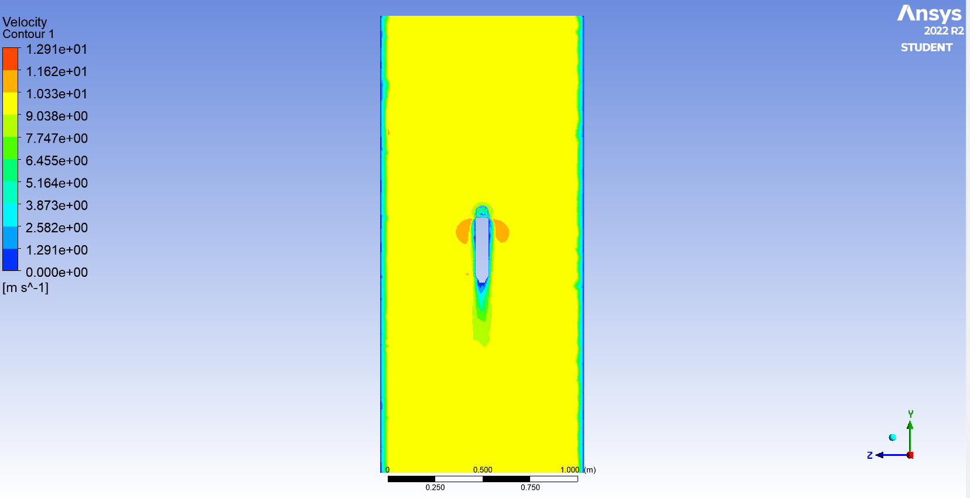

Figure 9 Sample tube velocity distribution

If we look at our velocity flow, it exhibits a very smooth flow and does not create a disruptive turbulence effect.

As a result of the analysis, it was seen that the drag force obtained while pulling the sample tube up with 10m/s was 18 Newtons.

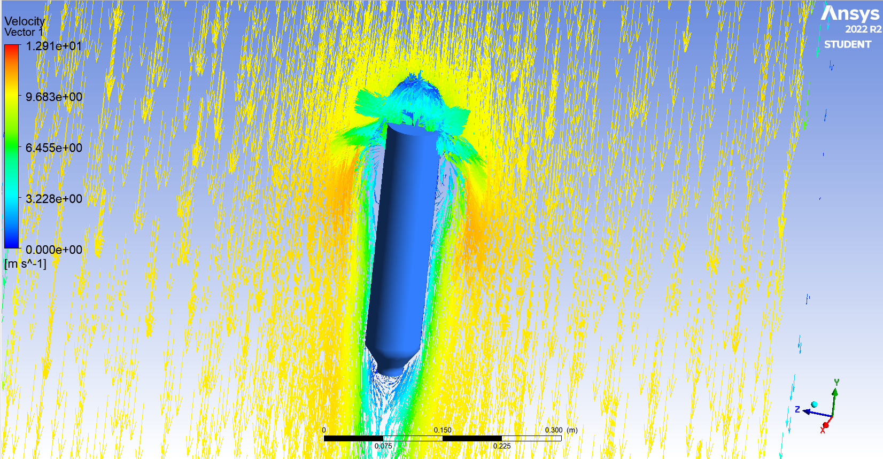

Figure 10 Sample tube velocity vector

* 1. **Horizontal Force Analysis**

Then, the Marmara Sea underwater current reports were examined in order to find the horizontal force acting on the sample tube and it was observed that the underwater currents were at very low speeds. 1m/s was accepted as the maximum horizontal flow and analyzes were made in this direction.

In order to find the drag coefficient and force brought by the stream flowing into the sample tube at a speed of 1m/s, flow analysis was performed with the fluent module over the Ansys program. The model was transferred to Ansys with a ratio of 1:1. The laminar turbulence model was used and the analyzes were made with these presuppositions. Below are the analysis results of the horizontal drag force.

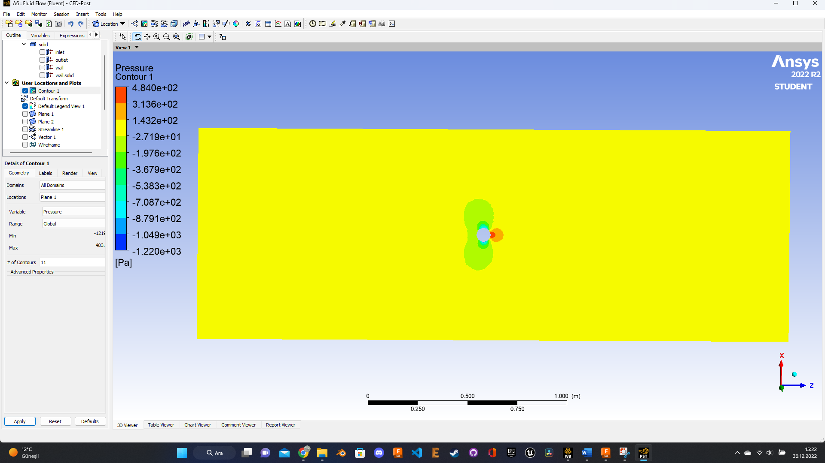

Figure 11 Top view pressure distribution

As it can be seen, although the flow causes a small pressure change in the horizontal plane, it does not show a remarkable disruptive effect.

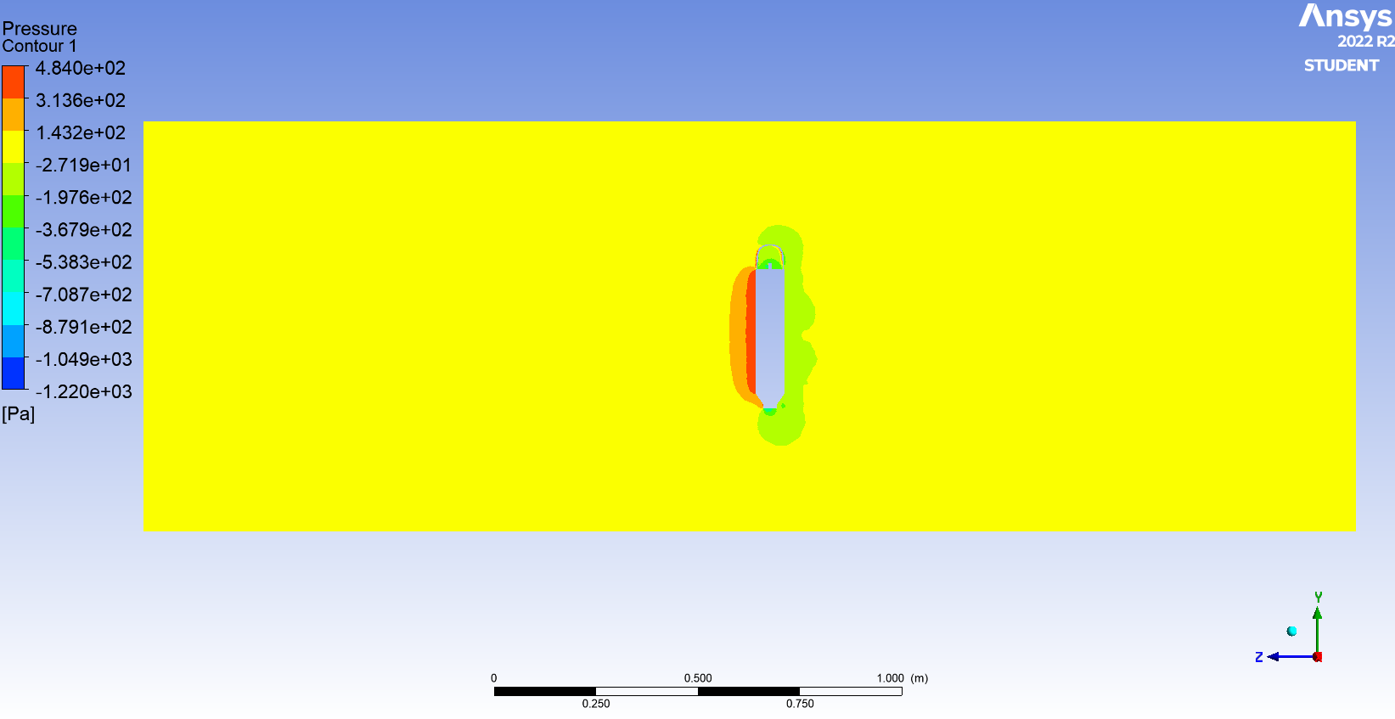

Figure 12 Side view Pressure distribution

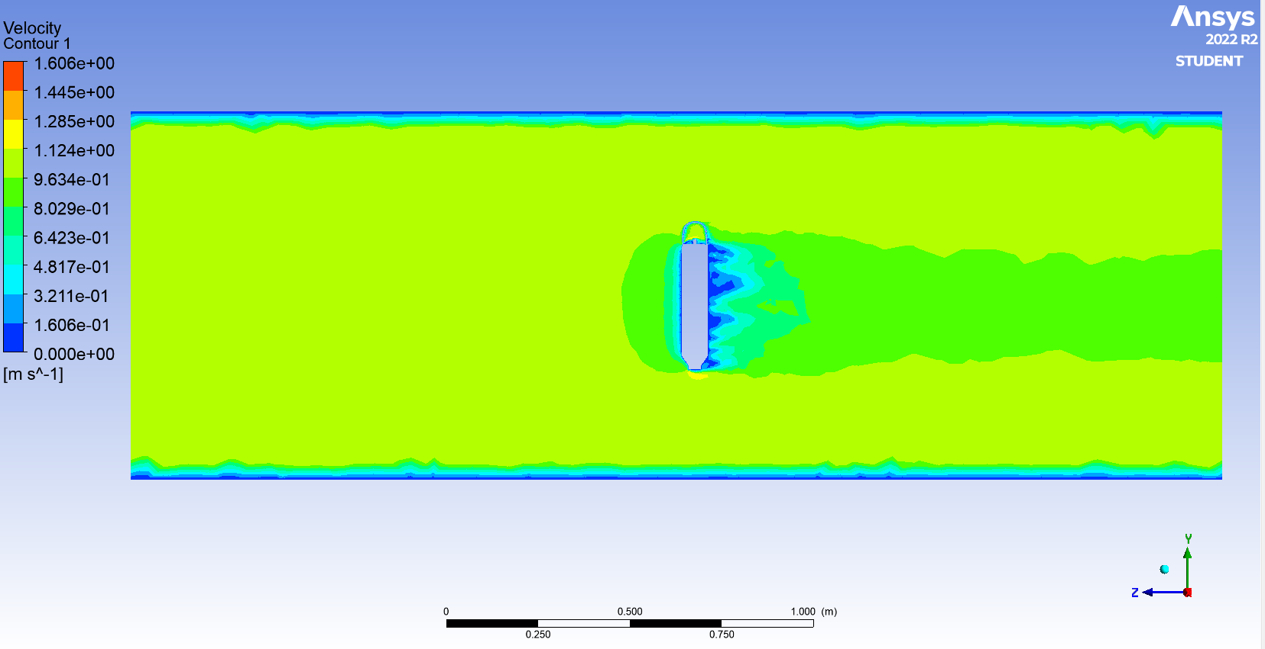

Figure 13 Side view Speed distribution

As a result of the analysis, it was seen that there was a drag force of 0.5 Newton. Since this force is negligibly small, it has not been taken into account for ease of calculation.